

**COMSATS** **University Islamabad, Lahore**



**Terminal Examination –FALL2019**

|  |  |  |  |  |  |  |  |  |  |
| --- | --- | --- | --- | --- | --- | --- | --- | --- | --- |
| Course Title: | Web Technologies, | | | | Course Code: | | CSC337, CSD337 | Credit Hours: | 4(3,1) |
| Course Instructor/s: | Muhammad Usman Akram, | | | | Programme Name: | | BSCS, BSSE | | |
| Semester: | 5,6,7 | Batch: | SP15,  FA15 | Section: | A, B, C, A (R) | | Date: |  | |
| **Time Allowed:** | **3 Hour** | | | | **Maximum Marks:** | | | **50** | |
| Student’s Name: |  | | | | Reg. No. |  | | | |
| **Important Instructions / Guidelines:**   * Give Precise Answers in the space provided. Avoid Writing Long Stories. * Attempt all questions. | | | | | | | | | |

**Question No 1 [10 Marks]**

Consider the following HTML code segment and its output given in Figure 1 and fill out the CSS in respective selectors which should produce this output.

<div class="header">

      <div id="logo">

        <img src="logo.png" width="50px" />

      </div>

      <div class="menu">

        <ul id="topMenu">

          <li><a href="">link</a></li>

          <li><a href="">link</a></li>

          <li><a href="">link</a></li>

          <li><a href="">link</a></li>

        </ul>

      </div>

    </div>

    <div id="container">

      <div class="super">Im the boss</div>

      <div class="right">

        <ul id="sideMenu">

          <li><a href="">link</a></li>

          <li><a href="">link</a></li>

          <li><a href="">link</a></li>

          <li><a href="">link</a></li>

        </ul>

      </div>

      <div class="left">

        <h3>This is Announcement</h3>

        <p>Web coding rocks!</p>

        <h3>This is Announcement</h3>

        <p>Web coding rocks!</p>

        <h3>This is Announcement</h3>

        <p>Web coding rocks!</p>

      </div>

      <p class="lorem">

        Lorem ipsum dolor, sit amet consectetur adipisicing elit. Repellendus,

        enim quasi? Laboriosam possimus ducimus quos dolor quam nisi iste

        nesciunt error earum eius et asperiores, recusandae harum? Ex, quos

        voluptatum?

      </p>

    </div>

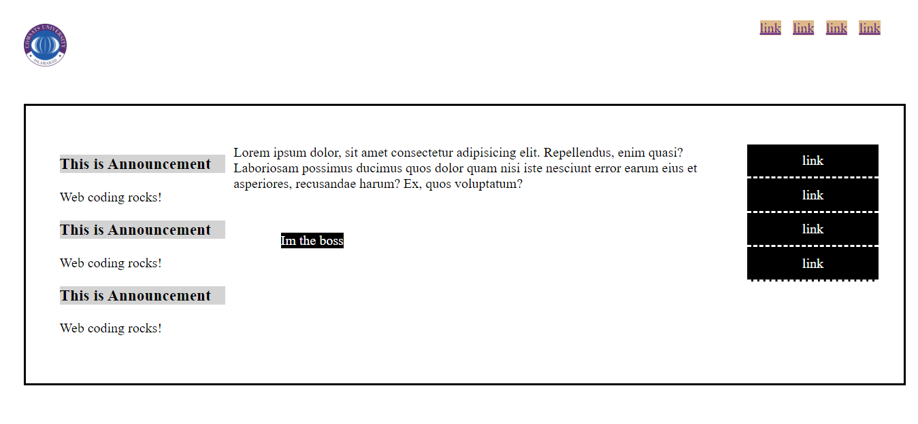

Figure 1 Code Output

Answer

#logo {

}

.menu {

}

#topMenu li {

}

#topMenu li {

}

.header {

}

.left {

}

.right {

}

#container {

}

.left h3 {

}

#sideMenu {

}

#sideMenu li {

}

#sideMenu li a {

}

.super {

}

Table -1

|  |  |  |
| --- | --- | --- |
| Question No. | Learning Objective/s | Critical Analysis |
| 1,2 | Students should be able to understand HTML/CSS/ bootstrap | Conceptual level, Comprehension & application, |

**Question No 1 [10 Marks]**

#logo {

  float: left;

  width: 10%;

  padding: 20px;

}

.menu {

  float: right;

  width: 80%;

  text-align: right;

  padding-right: 50px;

}

#topMenu li {

  background-color: burlywood;

  margin-left: 10px;

}

#topMenu li {

  display: inline;

}

.header {

  overflow: hidden;

}

.left {

  float: left;

  width: 20%;

  margin: 10px;

}

.right {

  float: right;

  width: 20%;

}

#container {

  border: 2px solid;

  overflow: hidden;

  position: relative;

  padding: 30px;

  margin: 20px;

}

.left h3 {

  background-color: lightgray;

}

#sideMenu {

  list-style-type: none;

}

#sideMenu li {

  text-align: center;

  background-color: black;

  padding: 10px;

  border-bottom: 2px dashed white;

}

#sideMenu li a {

  color: white;

  text-decoration: none;

}

.super {

  background-color: black;

  color: white;

  position: absolute;

  left: 300px;

  top: 150px;

}